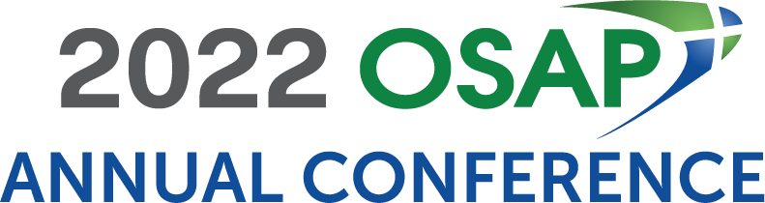
Dear <Supervisor’s Name>:

I would like to participate in the 2022 OSAP Annual Conference, held in Minneapolis, MN, from June 16 – 18, 2022, at the Hyatt Regency Minneapolis.

The 2022 OSAP Annual Conference will provide vibrant programming, impactful networking, and opportunities to reflect and connect over emerging and salient topics in dental infection prevention, occupational health, and patient safety. It will include opportunities for learning and engagement, including plenary sessions, concurrent sessions, and space to connect with sponsors, exhibitors, and innovative thinkers in dental infection prevention, occupational health, and patient safety from across the globe.

Registration provides me with:

- 17.5 hours of live educational sessions
- Access to 17.5 hours of on-demand session recordings for 60 days (starting July 8)
- Live Q & A with speakers
- Access to presentation materials (PowerPoints, resources, etc.)
- 17.5 hours of ADA CERP CE Credits
- Ability to network with OSAP board members, speakers, participants, and exhibitors throughout the conference
- And more!
OSAP’s top priority is the health and safety of all participants, exhibitors, vendors, speakers, and OSAP staff. As the COVID-19 situation evolves, OSAP may update its Health and Safety Policy to meet current science and evidence-based guidance.

After reviewing the course materials, I have identified several educational sessions that will allow me to gain knowledge and understanding about how we can improve our internal processes related to patient and provider infection control and safety. The presentations are facilitated by scientific experts and oral health colleagues who have faced similar challenges and are directly applicable to my work. I specifically chose these presentations because they directly relate to <insert issue your facility is currently dealing with>.

- <insert the session title and description>
- <insert the session title and description >
- <insert the session title and description >

I am seeking financial support for the registration fee for the conference. If I register by Thursday, April 21, I will be able to take advantage of the early-bird rate of $615 (OSAP Member)/$775 (Non-Member).

The opportunity for me to develop valuable contacts and gain knowledge in specific areas of my job makes my attendance a wise investment. Please consider my attendance. I’ll be glad to provide any additional information that you need to make a sound decision.

Sincerely,

<your name>

