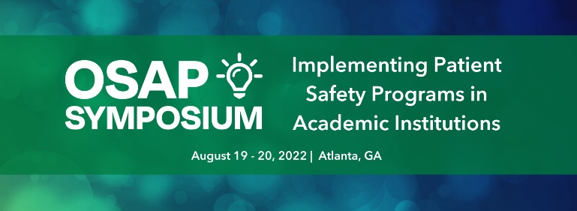
Dear <Supervisor’s Name>:

I would like to participate in the 2022 OSAP Symposium: Implementing Patient Safety Programs in Academic Institutions, held in Atlanta, GA, from August 19 – 20, 2022, at the Crowne Plaza Atlanta Perimeter at Ravinia.

The 2022 OSAP Symposium is a 1.5-day event focused on implementing a robust patient safety program in dental academic institutions. The symposium will include interactive sessions focused on tools for implementation, curriculum development, accreditation, research opportunities, and quality improvement (QI). There will be opportunities for networking throughout, including a networking reception on Friday night.

Registration provides me with:

- 10.5 hours of live educational sessions
- Access to 9 hours of on-demand session recordings for 60 days (starting September 9)
- Live Q & A with speakers
- Access to presentation materials (PowerPoints, resources, etc.)
- 10.5 hours of ADA CERP CE Credits
- Ability to network with OSAP board members, speakers, participants, and sponsors throughout the symposium
- Networking reception on Friday, August 19
OSAP’s top priority is the health and safety of all participants, exhibitors, vendors, speakers, and OSAP staff. As the COVID-19 situation evolves, OSAP may update its Health and Safety Policy to meet current science and evidence-based guidance.

After reviewing the course materials, I have identified several educational sessions that will allow me to gain knowledge and understanding about how we can improve our internal processes related to patient and provider infection control and safety. The presentations are facilitated by scientific experts and oral health colleagues who have faced similar challenges and are directly applicable to my work. I specifically chose these presentations because they directly relate to <insert issue your facility is currently dealing with>.

- <insert the session title and description>
- <insert the session title and description >
- <insert the session title and description >

I am seeking financial support for the registration fee for the conference. If I register by Friday, July 8, I will be able to take advantage of the early-bird rate of $375 (OSAP Member)/$535 (Non-Member).

The opportunity for me to develop valuable contacts and gain knowledge in specific areas of my job makes my attendance a wise investment. Please consider my attendance. I’ll be glad to provide any additional information that you need to make a sound decision.

Sincerely,

<your name>

